Visual Literacy
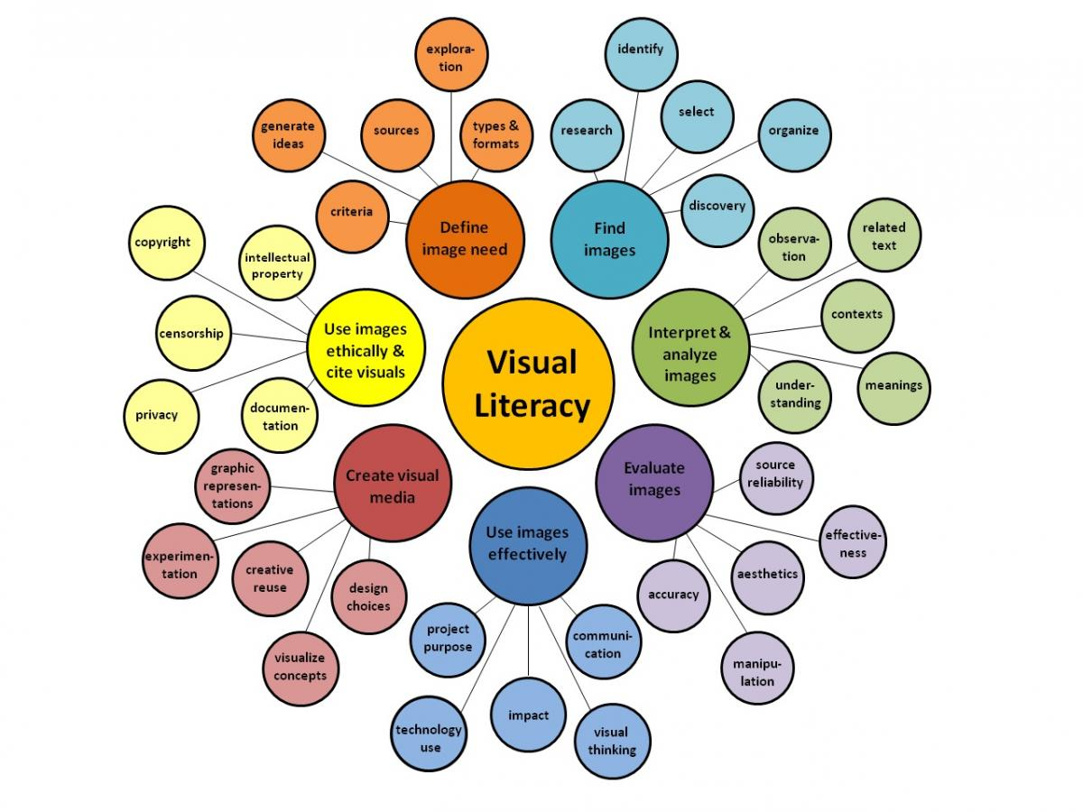

Only read this and don’t use it as example picture

The first written response on your diploma exam will be a Visual Reflection.
- What is a Visual Reflection?
Read this
- How do I write a Visual Reflection?
When writing a visual refection, it is very helpful to know terminology of visual elements. These are elements you can look for and comment on.
Test your visual literacy skills now!
Do this

What is Visual Literacy?
The ability to understand and use images, including the ability to think, learn, and express oneself in terms of images (Braden & Hortin, 1982, p. 41).
- Find and post an image that you believe is a good example of Visual Literacy to the Interactivity #1 topic on the Discussion Board
- Explain why your image (or images) is a good example of Visual Literacy
- Use terms provided in the 'test your visual literacy skills' link above

